**Dropping the Electric Geometric Network**

1. Drop all versions except sde.default.  
    as sde run “delete from sde.versions where name<>’DEFAULT’;”
2. Run a compress from ArcCatalog.
3. Ensure there are no connections to the database.
4. Open a command prompt, log into sqlplus as EDGIS, and run the ‘pm_order_number_idx_delete.sql’ script at the following location:  
   <http://edappgistfsprd1:8080/tfs/ElectricDistCollection/EDAMGIS/_versionControl#path=%24%2FEDAMGIS%2FSource_Development%2FDocumentation%2FData+Model%2FSchema%2FIndexes&_a=contents>
5. Connect to the database in ArcCatalog as business owner
6. Add the following buttons to the toolbar: Unregister as Versioned, Register as Versioned, Initialize Electric Trace Weights

Will look like:  

1. Export the connectivity rules via GDBDesigner or use a provided file from the DataModel Team.
2. Select the ElectricDataset
3. Unregister as Versioned.
4. Open the ElectricDataset and select the ElectricDistNetwork
5. Delete it
6. Steps 12 – 14 should be run on a batch server for access to the log files.
7. Browse to the following location and delete any existing “FdrMgrWeightInitSql.txt” and “FdrMgrWeightInitLastStatement.txt” files.  
   Documents and Settings\[User]\Application Data\Miner and Miner\ArcFM  
   or  
   Users\[User]\AppData\Roaming\Miner and Miner\ArcFM
8. Press “Initialize Electric Trace Weights” button : 
   1. This step must be verified that it ran successfully. It does *not* tell you if anything failed, and success must be determined by reviewing the log files.
   2. Browse to the same location as above and use the “FdrMgrWeightInitLastStatement.txt to gauge the progress. It will execute the sql statements in “FdrMgrWeightInitSql.txt” file in order.
   3. When finished, the statement listed in “FdrMgrWeightInitLastStatement.txt” will match the very last statement in “FdrMgrWeightInitSql.txt” file. If it doesn’t, then the initialize electric trace weights failed! The “FdrMgrWeightInitLastStatement.txt” file will have the feature class it was working on last – there is an issue that needs to be resolved with this feature class before the Initialize can be run again.
9. Right click on the Dataset and select ‘New Geometric Network’
10. Name: ElectricDistNetwork.
11. Leave the snapping set to **NO** (Unless this is an initial load of new data mostly used in conversion, never again!)

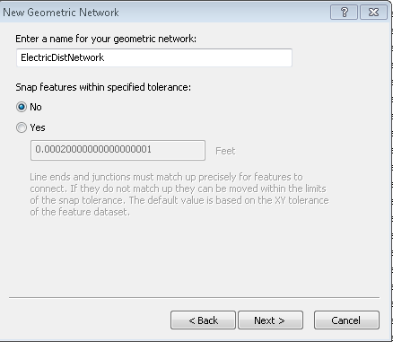

1. Select the feature classes you want in the network

|  |  |  |  |
| --- | --- | --- | --- |
| **Number** | **Feature Name** | **Role In Network** | **Source or Sink** |
| 1 | CapacitorBank | Simple Junction |  |
| 2 | DCConductor | Simple Edge |  |
| 3 | DCRectifier | Simple Junction |  |
| 4 | DCServiceLocation (9.x) | Simple Junction |  |
| 5 | DeliveryPoint | Simple Junction |  |
| 6 | DistBusBar | Simple Edge |  |
| 7 | DynamicProtectiveDevice | Simple Junction |  |
| 8 | ElectricStitchPoint | Simple Junction | Source |
| 9 | FaultIndicator | Simple Junction |  |
| 10 | Fuse | Simple Junction |  |
| 11 | NetworkProtector (8.x) | Simple Junction |  |
| 12 | OpenPoint | Simple Junction |  |
| 13 | PrimaryGeneration | Simple Junction |  |
| 14 | PrimaryMeter | Simple Junction |  |
| 15 | PrimaryRiser | Simple Junction |  |
| 16 | PriOHConductor | Simple Edge |  |
| 17 | PriUGConductor | Simple Edge |  |
| 18 | SecOHConductor | Simple Edge |  |
| 19 | SecondaryGeneration | Simple Junction |  |
| 20 | SecondaryLoadPoint | Simple Junction |  |
| 21 | SecUGConductor | Simple Edge |  |
| 22 | ServiceLocation | Simple Junction |  |
| 23 | SmartMeterNetworkDevice | Simple Junction |  |
| 24 | StepDown | Simple Junction |  |
| 25 | Streetlight | Simple Junction |  |
| 26 | Switch | Simple Junction |  |
| 27 | Tie | Simple Junction |  |
| 28 | Transformer | Simple Junction |  |
| 29 | TransformerLead | Simple Edge |  |
| 30 | VoltageRegulator | Simple Junction |  |

1. Press next

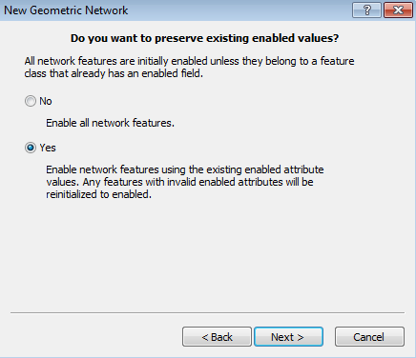

1. Change the role for **ElectricStitchPoint** to SOURCE like below

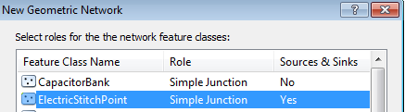

1. After all set hit next button.
2. Assign **MMElectricTraceWeight** to the features (select the ElectricTraceWeight field) (you must spell exactly as written – case sensitive)

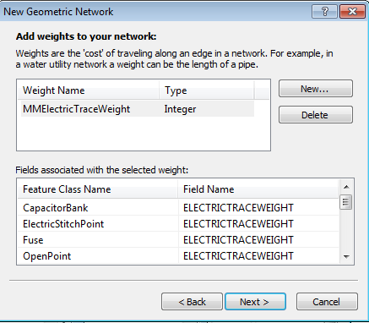

* 1. NOTE Make sure you get all features. Many people have missed this step and it will cause you to rebuild the whole network again.

1. Review the summary page and hit next
   1. The actual build of the network may take a long time. Please do not kill the ArcCatalog application, it is running, honest.
   2. If you receive the following error, click OK and continue with the steps. It is expected when changing network configuration:  
      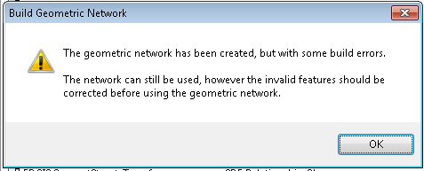
2. Use GDB Designer to load the connectivity rules, using the file created above.
3. Create the VERSIONNAME field on the ElectricDistNetwork_Junctions feature class:  
   Name: VERSIONNAME  
   Type: Text

Alias: Version Name  
Allow Nulls: Yes

Length: 64

1. Execute the following script to create the FEEDERTYPE and CIRCUITID fields. Change the SDE file to the appropriate database, connection, and user (EDGIS).  
   
2. Now open arccatalog and copy the very latest cached tracing table (EDGIS.PGE_ELECDISTNETWORK_TRACE) to this database. For example in System Test I am copying the EDGISP2T cached tracing table to our LBGISS2Q database, so from publication to maintenance. This copy and paste requires a rename of the file, use the name TEMP_EDNETWORK_TRACE as the table name.
3. Run the following SQL to update the CIRCUITID on network junctions:

set timing on    
merge INTO edgis.electricdistnetwork_junctions ej  
  USING(  
  select a.TO_FEATURE_GLOBALID,min(a.FEEDERID) FEEDERID,min(b.feedertype) FEEDERTYPE  
  from ( select TO_FEATURE_GLOBALID,min(FEEDERID) FEEDERID from   
               edgis.temp_ednetwork_trace   
      where to_feature_fcid=19469   
      group by TO_FEATURE_GLOBALID)a  
  inner join   
  (select circuitid,feedertype from   
                     edgis.circuitsource   
      group by circuitid,feedertype   
      having count(*)=1   
  ) b on a.feederid=b.circuitid   
  group by a.TO_FEATURE_GLOBALID  
  ) updateinfo  
  ON (ej.globalid=updateinfo.TO_FEATURE_GLOBALID)  
 WHEN MATCHED THEN UPDATE SET EJ.CIRCUITID=updateinfo.feederid , ej.FEEDERTYPE=updateinfo.FEEDERTYPE ;

merge INTO edgis.A1166280 ej  
  USING(  
  select a.TO_FEATURE_GLOBALID,min(a.FEEDERID) FEEDERID,min(b.feedertype) FEEDERTYPE  
  from ( select TO_FEATURE_GLOBALID,min(FEEDERID) FEEDERID from   
               edgis.temp_ednetwork_trace   
      where to_feature_fcid=19469   
      group by TO_FEATURE_GLOBALID)a  
  inner join   
  (select circuitid,feedertype from   
                     edgis.circuitsource   
      group by circuitid,feedertype   
      having count(*)=1   
  ) b on a.feederid=b.circuitid   
  group by a.TO_FEATURE_GLOBALID  
  ) updateinfo  
  ON (ej.globalid=updateinfo.TO_FEATURE_GLOBALID)  
 WHEN MATCHED THEN UPDATE SET EJ.CIRCUITID=updateinfo.feederid , ej.FEEDERTYPE=updateinfo.FEEDERTYPE ;

commit;

1. Delete the temporary table copied over in ArcCatalog "temp_ednetwork_trace"
2. Assign ArcFM Properties to the ElectricDistNetwork_Junctions feature class.
   1. Open the ElectricDataset and right click on the EDGIS.ElectricDistNetwork_Junctions feature class and click on ArcFM Properties Manager.
   2. Click on the Field Model Names Tab.
   3. Assign the following field model name
      1. VersionName
         1. PGE_VERSIONNAME field model name
      2. FeederType
         1. PGE_FEEDERTYPE field model name
      3. CircuitID
         1. FEEDERID
         2. PGE_CIRCUITID
   4. Click the Model Names tab.
   5. Assign the following class model names:
      1. Class model name: PGE_DMSCLASS
      2. Class model name: PGE_EDSCHEM_CHANGEDETECTION
      3. Class model name: PGE_FEEDERTYPE
   6. Click OK.
   7. Re-Open the ArcFM Properties manager.
   8. Click on the Object Info tab.
   9. Select the On Feature Create dropdown and select “<Multiple>”.
   10. Assign the following AUs for On Create
       1. PGE Record Version
       2. PGE Segment Split AU
       3. ArcFM Feeder Cache Maintenance
   11. Select OK.
   12. Select the On Feature Update dropdown and select “<Multiple>”.
       1. PGE Record Version
       2. ArcFM Feeder Cache Maintenance
   13. Select OK.
   14. Select the On Feature Delete dropdown and assign the ArcFM Feeder Cache Maintenance AU.

**NOTE:** If there is no other network to rebuild, continue here, otherwise do up to this point and come back to this document once all of them are to this point

1. Right click the ElectricDataset and Register as Versioned.
2. Right click the CustomerAgreement table in the root of the database and select Register As Versioned.
3. Right click the ElectricDataset and select ‘Add Global IDs…’.
4. Right click the ElectricDistNetwork_Junctions feature class and select ArcFM Properties Manager.
   1. Assign the following field model name:
      1. Field: GLOBALID
      2. Field model name: PGE_DMSFIELD
5. Log in as EDGIS using a temporary version in the SDE connection. Select the electric dataset – right click and select ArcFM Solution Object Converter (Note: logging in as SDE will not work.)

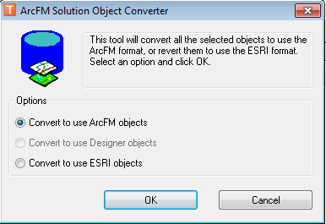

1. Log into the database as EDGIS.
2. All permissions must be reassigned because the data was un-versioned and versioned.  
   Assign privileges to all data in feature datasets of:

SDE_EDITOR

DAT_EDITOR

DATACONV - select only

DMSSTAGING - select only

SDE_VIEWER - select only

GIS_INTERFACE - select only

GISINTERFACE - select only

* 1. Assign privileges by right clicking the dataset and selecting Privileges.
  2. Type in the role, and select an option from each of the two following dropdowns for select and edit permissions.

1. Run the ‘pm_order_number_idx_create.sql’ script, located here:  
   <http://edappgistfsprd1:8080/tfs/ElectricDistCollection/EDAMGIS/_versionControl#path=%24%2FEDAMGIS%2FSource_Development%2FDocumentation%2FData+Model%2FSchema%2FIndexes&_a=contents>
2. Login as SDE.
3. Run “Inspect/Fix Source Weights” by right clicking on the network and selecting the option under the Feeder Manager menu.
   1. This is a verification step. If it reports anything as incorrect, then the initialize electric trace weights failed somewhere and it needs to be analyzed.
4. Run Trace all feeders, by right clicking on the network, if the data has been appended or changed in this process.

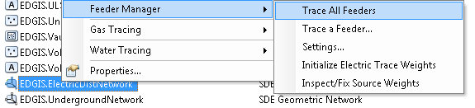

1. Open the following script and change the username, password, and database to the desired values.  
   
2. Execute the script from the command prompt on a machine with ArcGIS Server installed.

**Redefining the Schematic ElectricDistNetwork_Junction**

**These steps should be implemented after the network has been recreated.**

1. Browse to the new EDSCHM database connection

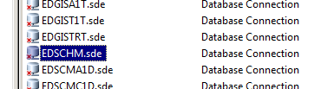

1. Log into the EDSCHM as the edgis user

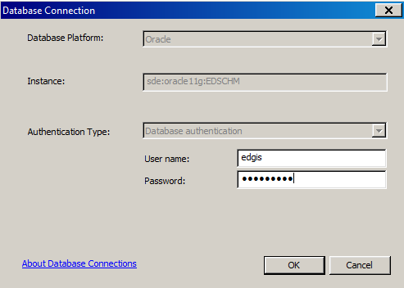

1. Right-click on the EDGIS.ED_SCHEMATICS and select ‘Edit…’

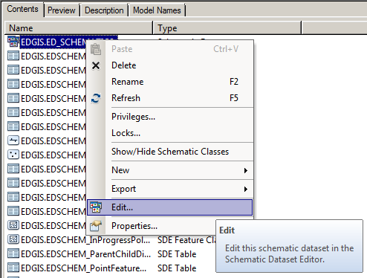

1. Log into the dataset as the edgis user again



1. Drop down the Circuit Map Template

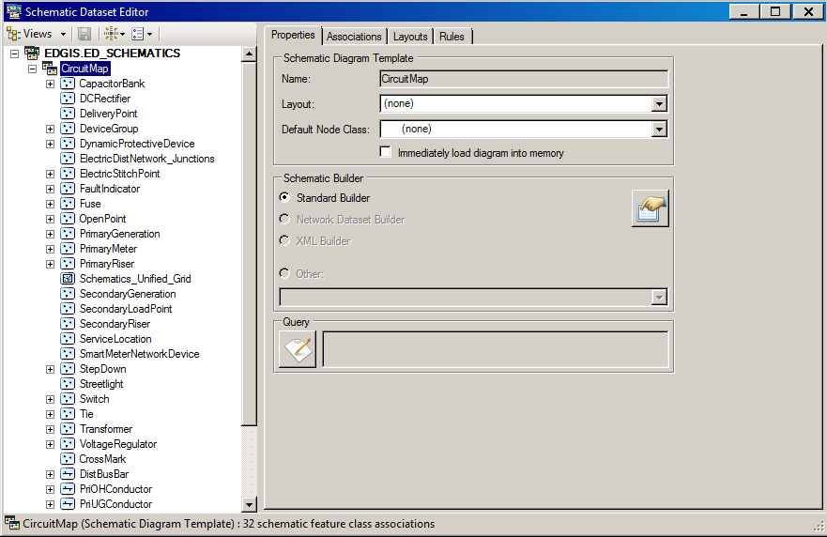

1. Click on the ElectricDistNetwork_Junction Schematic feature class.

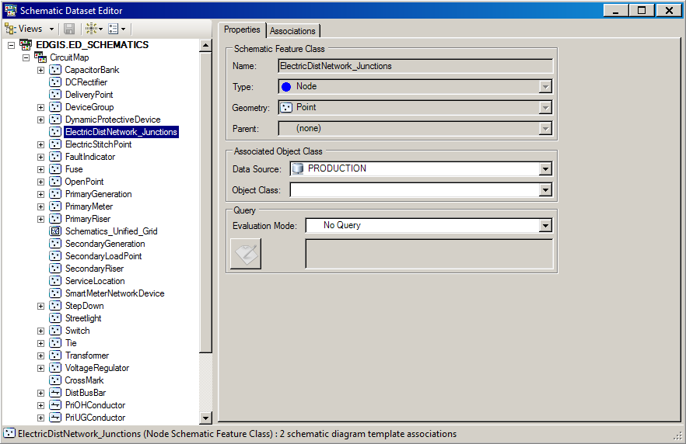

1. Select EDGIS.ElectricDistNetwork_Junction from the Object Class drop down.

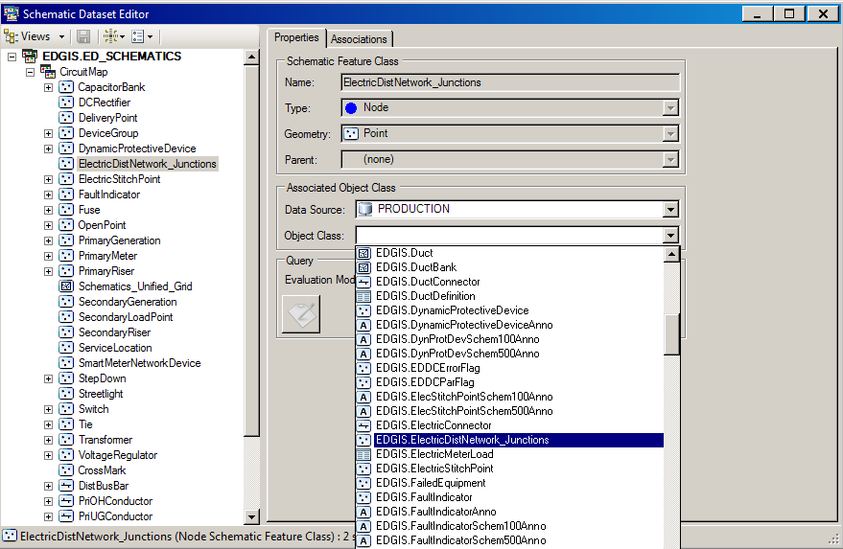

1. Save the Schematic Dataset

